Chapter 06: Colour Image Processing

Table of Contents

Colour Fundamentals 3

Colour Spaces 5

CIE XYZ 6

RGB Colour Model 8

Safe Colours 9

CMYK Model 10

HSI Model 11

Converting Between HSI and RGB 13

HSI Components 14

Basics of Full Colour Image Processing 17

Colour Complements 18

Histogram Processing 19

Image Smoothing 20

Image Sharpening 21

Image Segmentation 21

Edge Detection 24

Noise 26

Image Compression 27

Use of colour in image processing can be extremely beneficial for human consumption. The human eye is only capable of distinguishing 20 to 30 shades of grey, but it can identify thousands of shades of colour.

Colour image processing consists of two parts, pseudo-colour processing and full colour processing. In **pseudo-colour processing**, we assign colours to a monochrome image based on the intensity values. The only purpose for this is to make the different structures of the image easily identifiable by the human eye. In **full colour processing**, we process images that actually have colour.

## Colour Fundamentals

The human eye contains **cones** which are can each sense one of three colours, red, green and blue. This is called the **tri-stimulus model**. The combination of these three colours produces every shade of colour that we are capable of seeing.

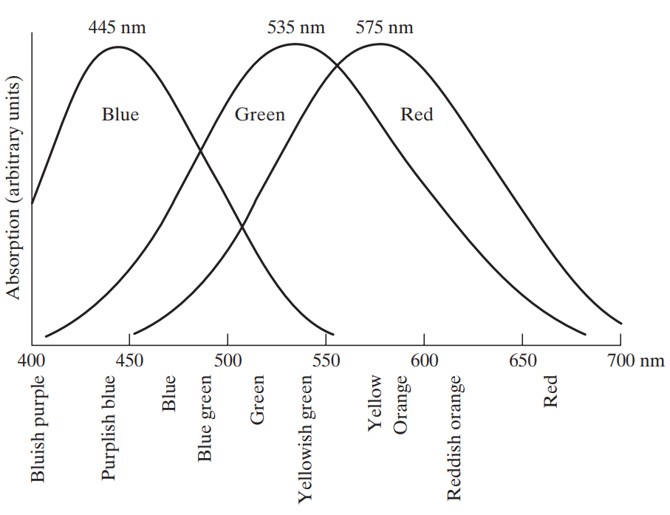

This phenomenon of combining these three colours to produce every other shade is described using two models, the additive model and the subtractive model. The **additive model** is used in references to a source of light, where we try to describe the colour of light being emitted by measuring the amount of red, green and blue in it.

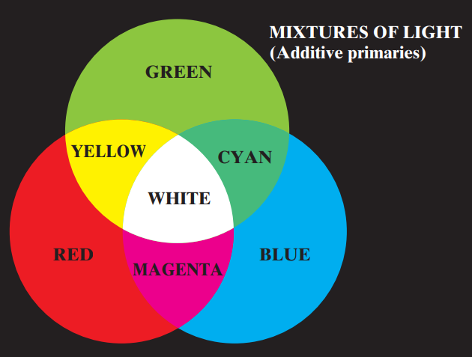

On the other hand, the **subtractive model** is used in references to reflected light, where we remove some amount of red, green or blue to determine what colour remains.

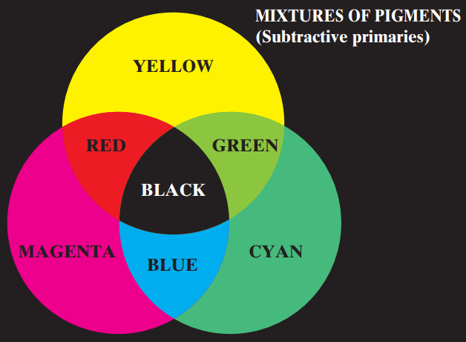

## Colour Spaces

So far, we have been describing colours as some mixture of red, green and blue. This is actually just one way in which we can describe colour. It is called the **RGB Colour Space** and is used when working with displays. We also have the **CMYK Colour Space**, which stands for Cyan, Magenta, Yellow, Black and is used when working with printed material, and the **HSI Colour Space**, which stands for Hue, Saturation and Intensity, and is used when manipulating colour components.

There are a few terminologies that we should be familiar with before going further:

* **Hue** – This is the dominant wavelength which describes the colour we are seeing.
* **Saturation** – This is a measure of the amount of white light mixed into the dominant wavelength.
* **Chromaticity** – This is the combination of Hue and Saturation.
* **Tristimulus Values** – The amount of red, green and blue used to form a particular colour.
* **Colour Gamut** – A range of colours.

## CIE XYZ

The **International Commission on Illumination** (CIE in French) provides a standard for sharing colour information between disciplines. This standard describes the entire visible gamut.

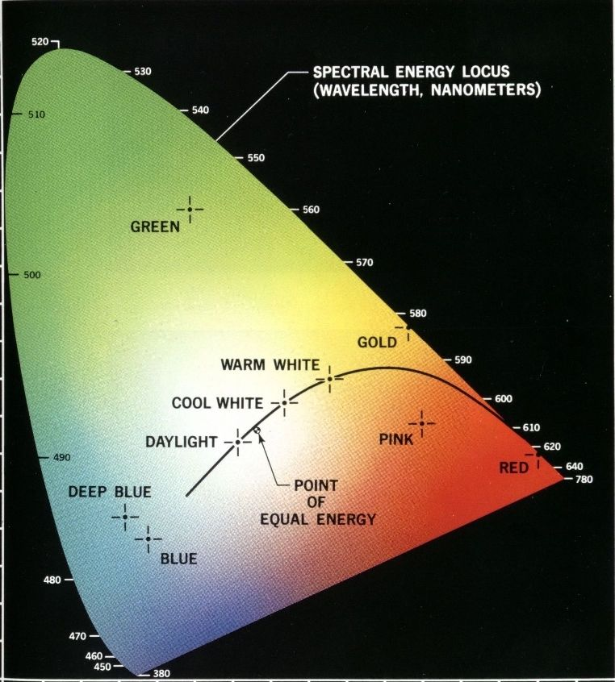

This diagram is called the **CIE Chromaticity Diagram**. We would have needed three axes for the three primary colours, but since red, green and blue values have been normalized, it all fits into 2 dimensions. Normalization means that $Z=1-X-Y$, which results in us being able to fit all three colours in the same plane.

Towards the edges of the diagram, we have **fully saturated** colours. As we go inside, the amount of white mixed increases. The centre point is called the **Point of Equal Energy**, meaning there is an equal amount of red, green and blue at that point.

Every digital device in the world uses a **point of reference** for the three primary colours. The diagram below shows an example of this.

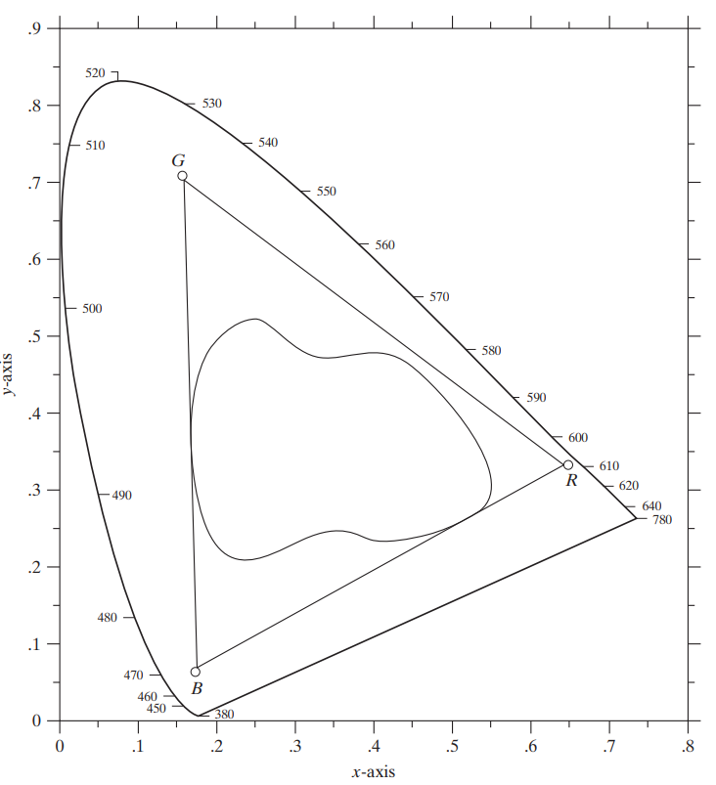

The triangle formed by the three points is the range of colours the device is capable of displaying. The larger the triangle, the better the display of colours by the device. Printing devices tend to have an irregularly shaped colour gamut, such as the curvy shape shown.

## RGB Colour Model

We can describe the RGB Colour Model as a cube.

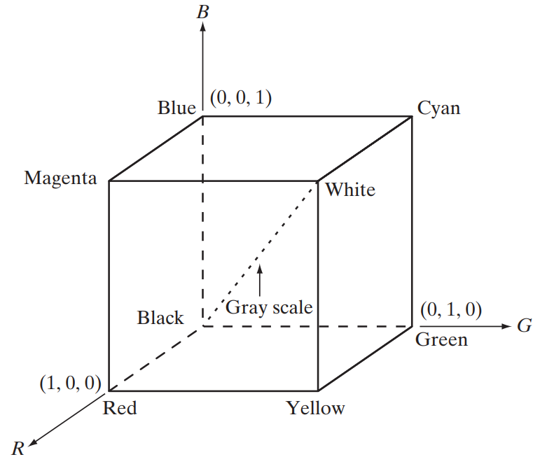 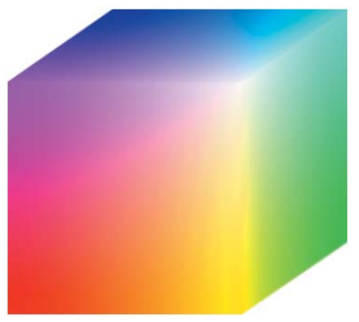

The cube holds $256×256×256=16777216$ separate colours for an 8-bit model. There are colours inside the cube as well.

If we draw a line between the backmost point (black) to the top-right-most point (white), the line will be a **greyscale line**.

For additive models used by hardware, this model is perfect. It is a part of CIE XYZ. However, it does not show all the visible colours, since the visible colour range is a continuous one and this is a discrete model.

### Safe Colours

A subset of the colours shown by the cube can be taken to produce the **safe-colour cube**. These colours are likely to be reproduced faithfully, reasonably independently of the hardware producing it.

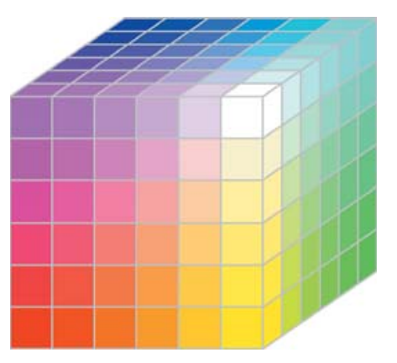

There are 216 such colours. The values for each of the three components seem random, but the hexadecimal equivalents follow a pattern.

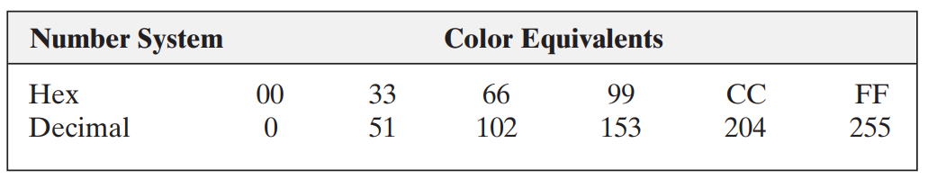

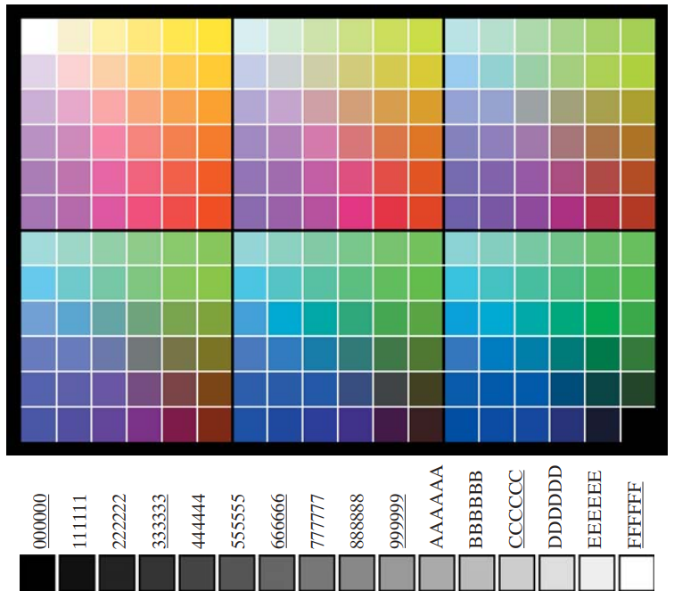

Of the 216 shades, 16 are greyscale shades. Additionally, there are also 40 **OS-dependent** colours which can be added to bring the total up to 256.

## CMYK Model

Things like paint, ink or dye subtract colour from white light and reflect back the rest. Mixing paint pigments can subtract multiple colours. The **CMYK Model** is the most common subtractive model. It is very important for printing devices.

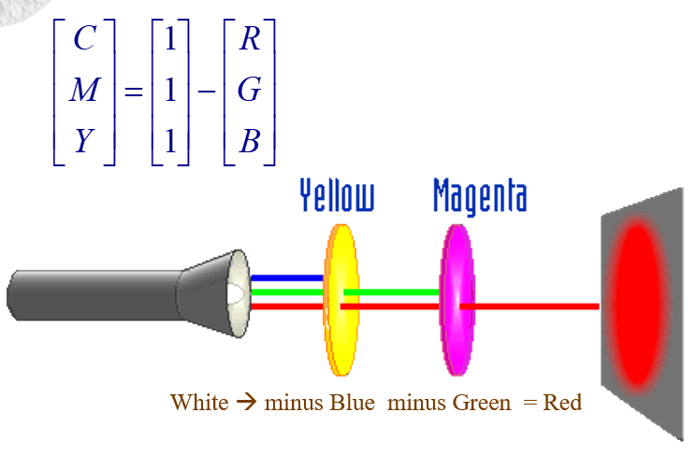

Theoretically, we can subtract all the colours to produce **black**. However, this will not be as dark as true black, since it is difficult to absorb all of the light energy and not have any reflected.

## HSI Model

With the **HSI Model**, the intensity component is decoupled from the colour components, as described by hue and saturation. This gives us a lot more power when processing or modifying images. Hue and saturation are closely related to how humans perceive colour, so modifying them without modifying intensity at the same time allows us to modify images in ways we cannot using the RGB or CMYK models.

For the HSI model, it is best to consider a circle. **Hue** determines the dominant colour we see and is a normalized measure (between 0 and 1) of the angle made with the $x$-axis. **Saturation** determines the amount of white mixed in and is measured by how far between the centre of the circle and the circumference we are.

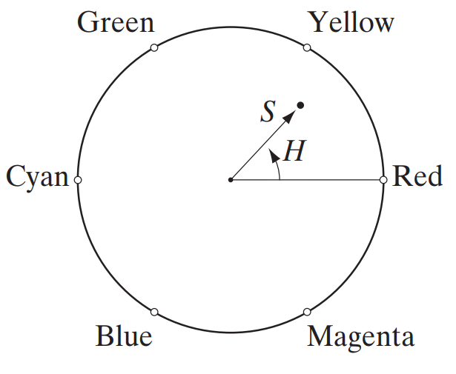

The circle concept comes from a hexagon concept, which in turn comes directly from an RGB cube.

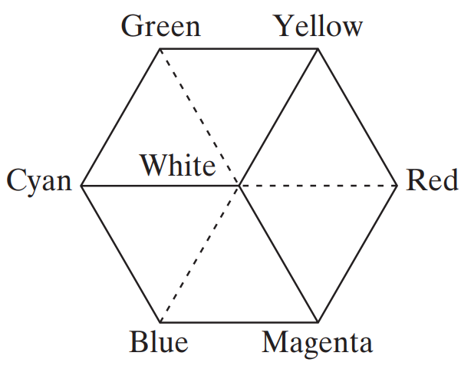 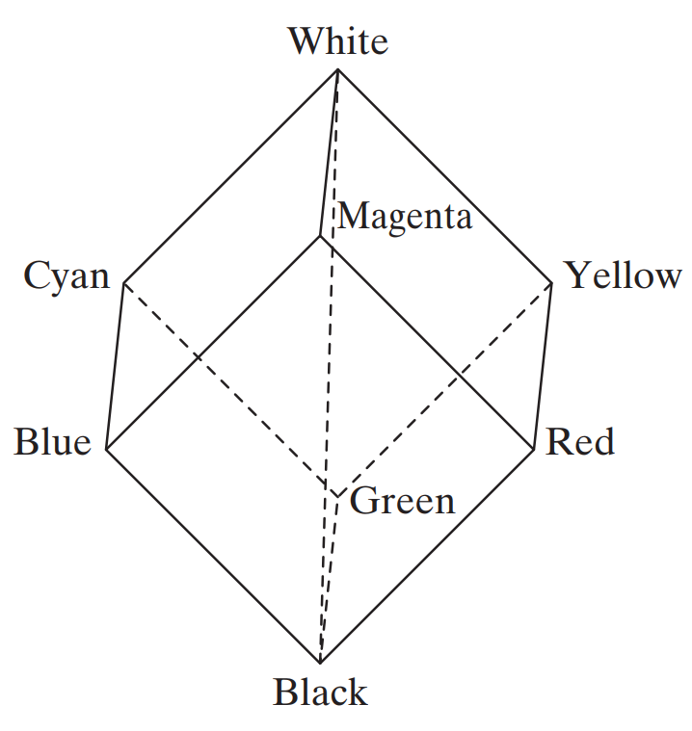

The hexagon is just a single **slice** from the cube. Depending on where we slice it, we will get a different **intensity** value.

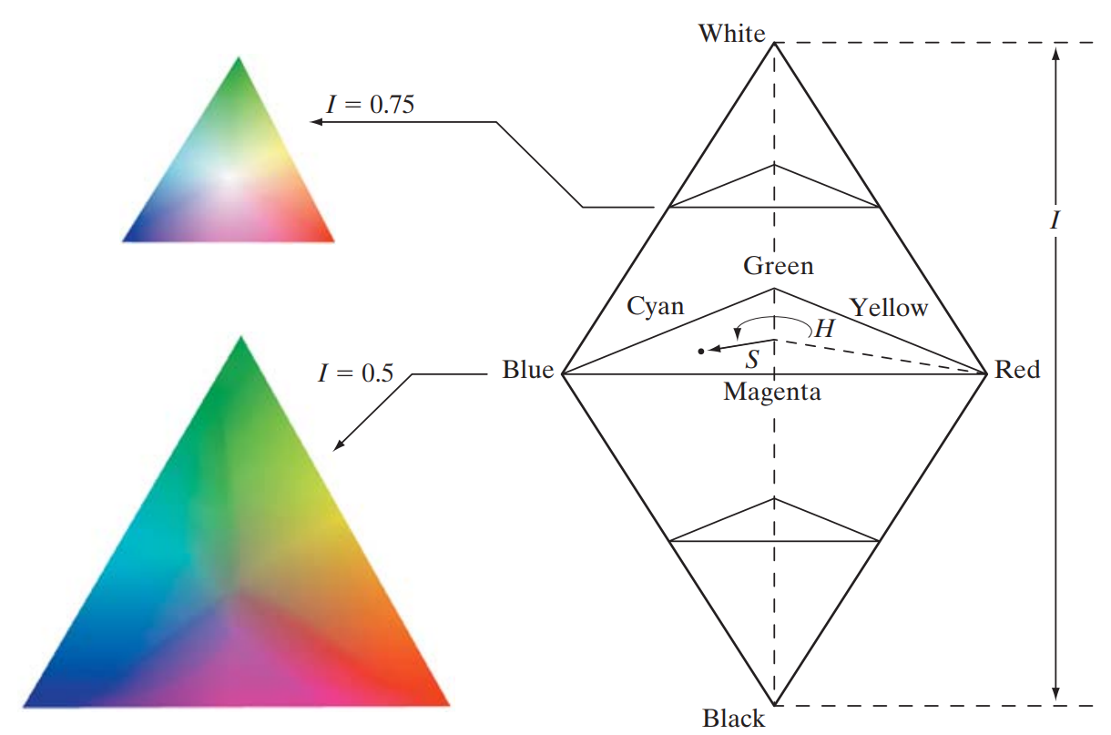

### Converting Between HSI and RGB

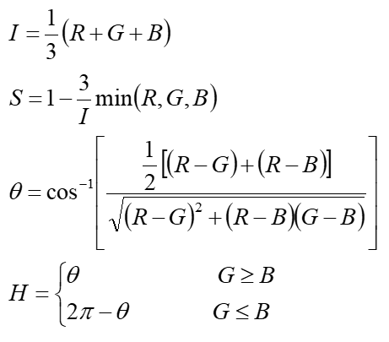

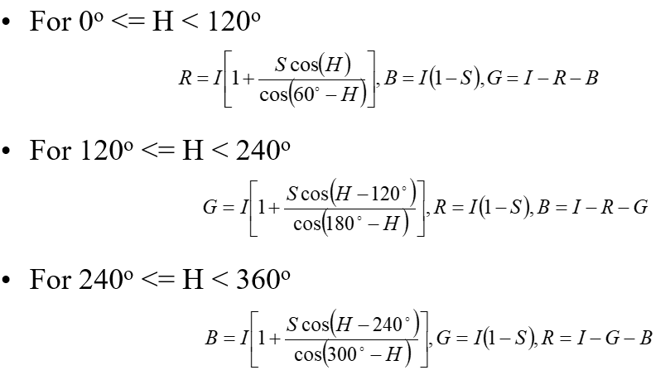

### HSI Components

The different components of the HSI model, Hue, Saturation and Intensity, can be viewed in the RGB space as shown below.

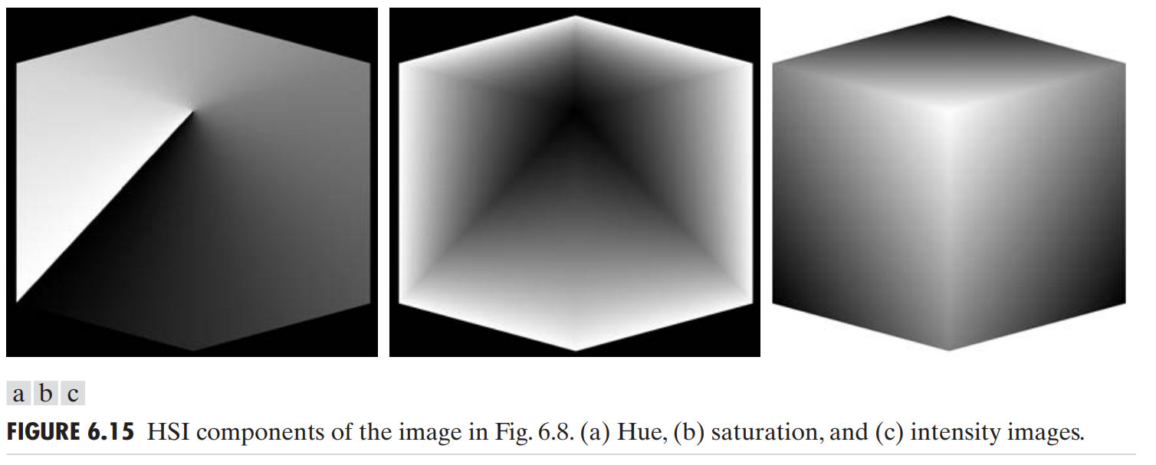

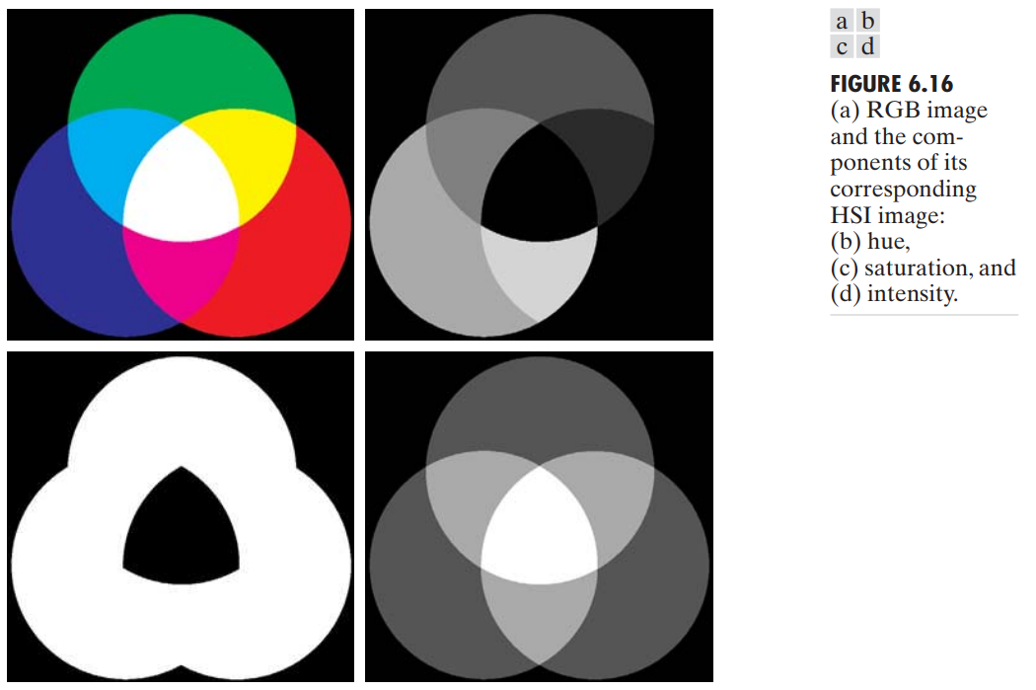

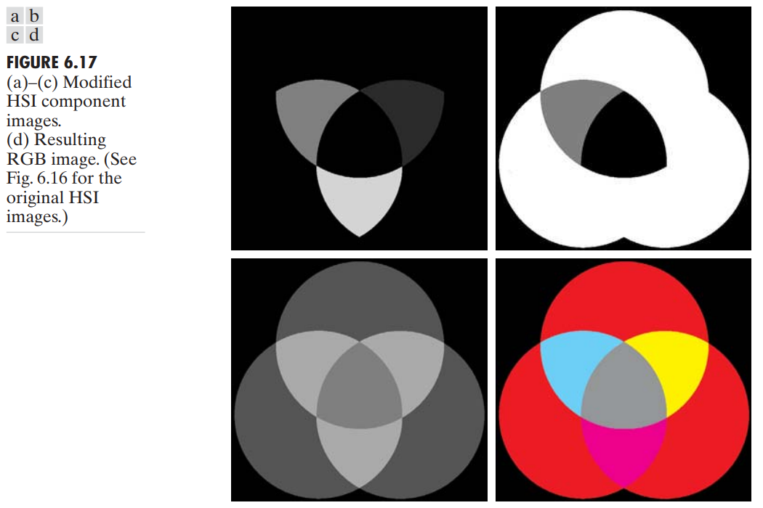



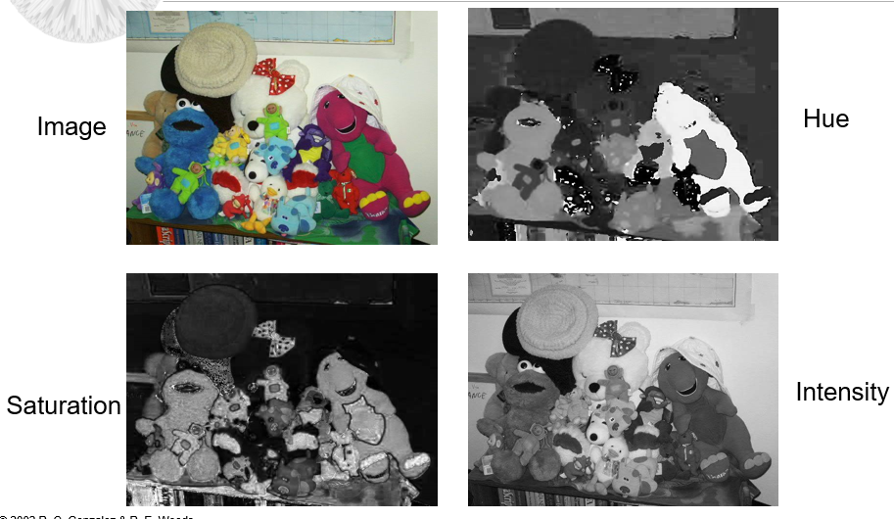

## Basics of Full Colour Image Processing

**Full Colour Image Processing** techniques fall into one of two categories. In the first category, we process each component of the image individually and combine them together. In the second category, we process the colour pixels directly.

When processing a colour image, the way in which we have to process it to achieve the desired effect depends on the colour model we use. For example, suppose we have to decrease the intensity of an image. The graphs for the transformations required in each of the RGB, CMY and HSI models is shown below. Notice that the hue and saturation remain unchanged in the HSI model.

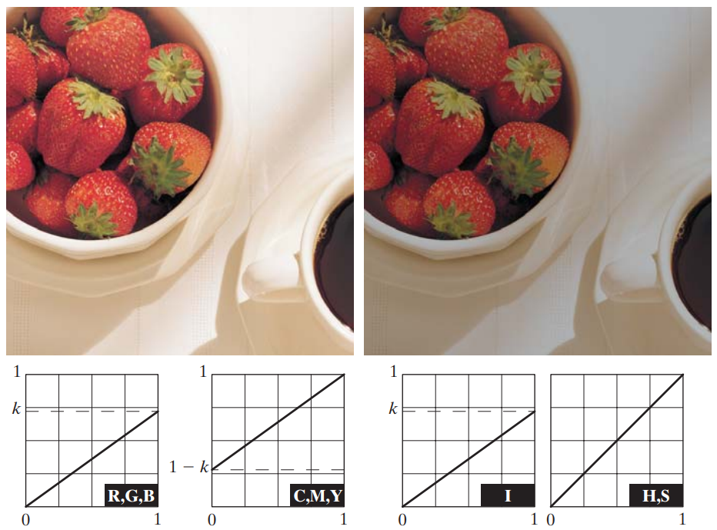

### Colour Complements

If we want to **invert** the colours of an image and create a negative image, doing so in the RGB model is easy enough. In the HSI model, we have to shift the hue by $180°$ (to get the opposite colour), reverse the intensity value and leave saturation unchanged.

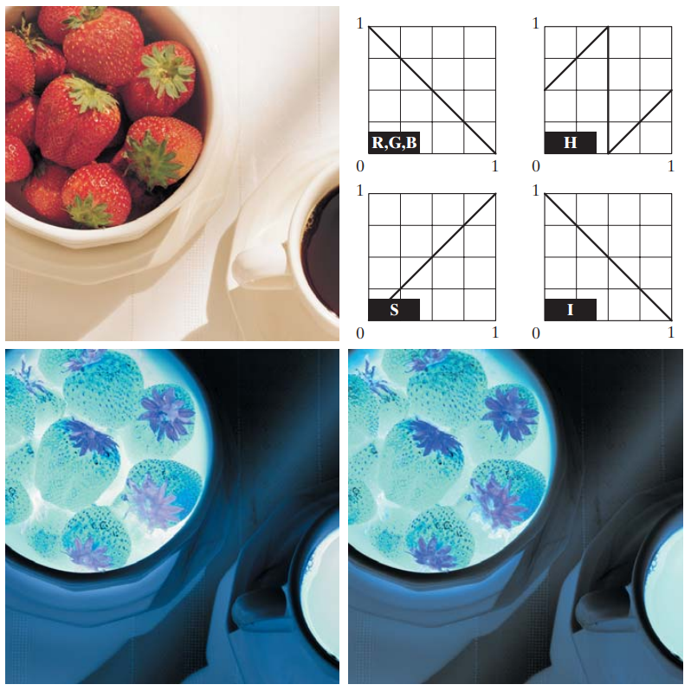

Using the circle from the HSI model will make it easy to see which colours are complements of each other.

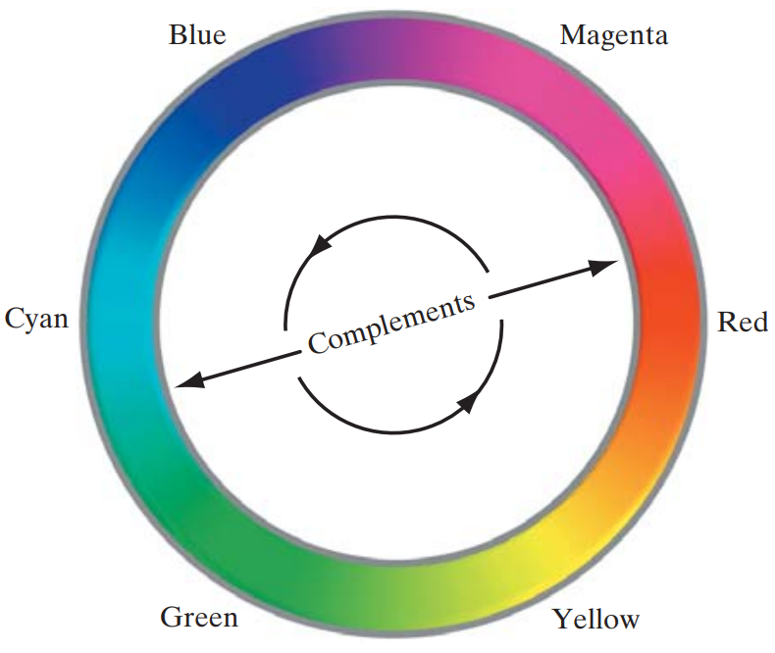

## Histogram Processing

When performing **histogram equalization**, in the RGB model, we just equalized each channel. In the HSI model however, we just equalize the intensity, since histogram equalization has nothing to do with colours.

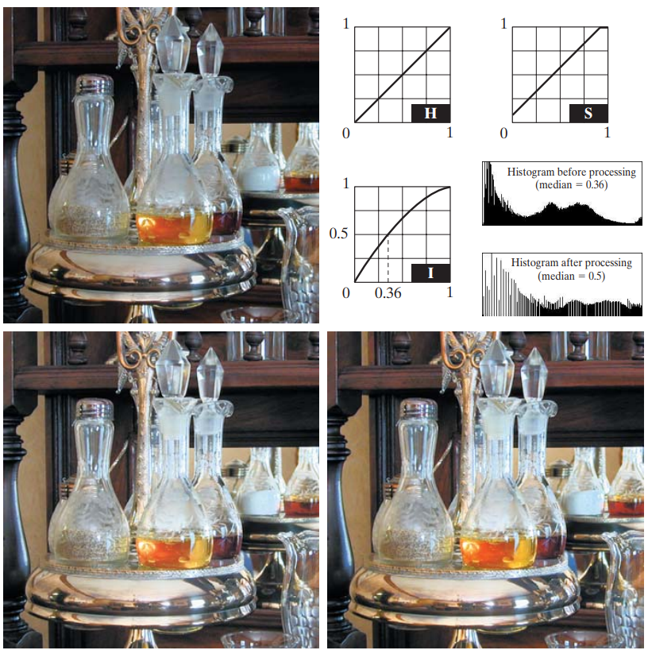

The bottom left image shown above is the result of histogram equalization on just the intensity channel. However, performing histogram equalization like this can lead to the colours looking **less vivid** than they did before. To fix this, we can **increase saturation** by a fixed amount. This is done in the image shown in the bottom right.

## Image Smoothing

When **smoothing** an image, we only care about the intensity values. So, as with the previous example, we will only modify the intensity channel for the HSI model. However, for the RGB model, we will be forced to modify all three channels.

If we perform the same amount of smoothing on both the RGB model and the HSI model, there will be no visible differences. However, if we subtract one image from the other, we will see that there are slight differences, specifically at the edges of the different structures in the image. These differences are visible since, for the RGB model, the colours are also modified to a certain extent when we perform smoothing.

## Image Sharpening

Similar to the smoothing process, the **sharpening** process using Laplacian filters also has a slight difference depending on whether we apply the filter to the red, green and blue channels individually as with the RGB model or to the intensity channel alone as with the HSI model. The difference between the two will again be around the edges.

## Image Segmentation

In **Colour Image Segmentation**, our goal is to segment an image based on colour. Suppose we have the following image and we want to segment out the region with red colours.

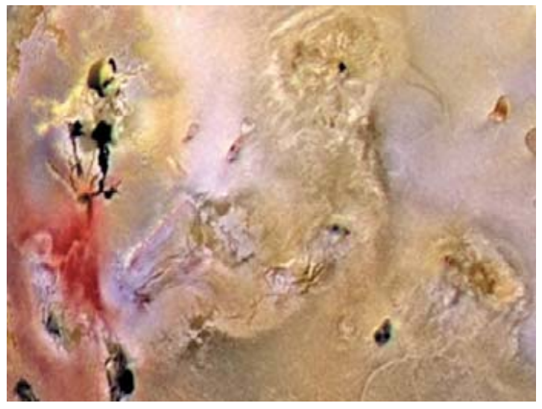

In the RGB model, we simply choose a specific combination of intensities from the red, green and blue channels. Suppose this is some vector $c$. In reality, having a strict measure of a specific combination of intensities is unlikely to return a proper segmentation, since ‘segment out the red section’ is vague and most likely covers a range of intensity values. To accommodate this, we allow for some **variance**, $σ$. This results in a spherical area of colours that we want to segment out.

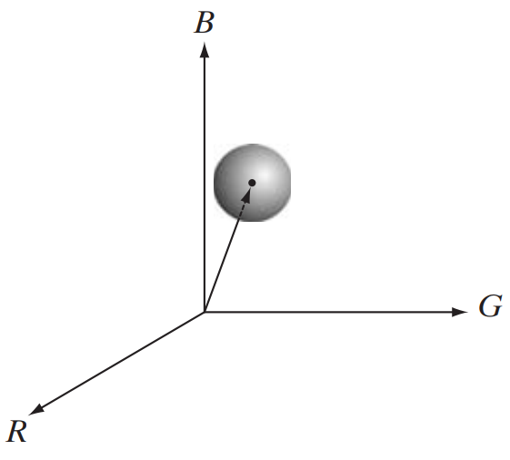

Since we are interested in the red region specifically, it makes sense to allow greater variance for the red channel than the blue or green channels. This gives us an **ellipsoidal shape**.

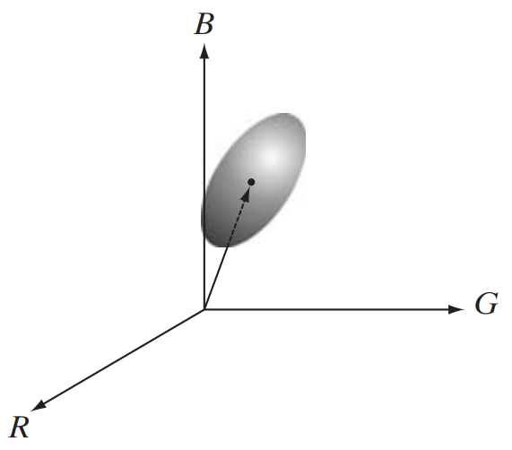

However, if we think about it, what we will actually end up getting is a **cube**, not a sphere, since we are adding a constant term to each of the three dimensions.

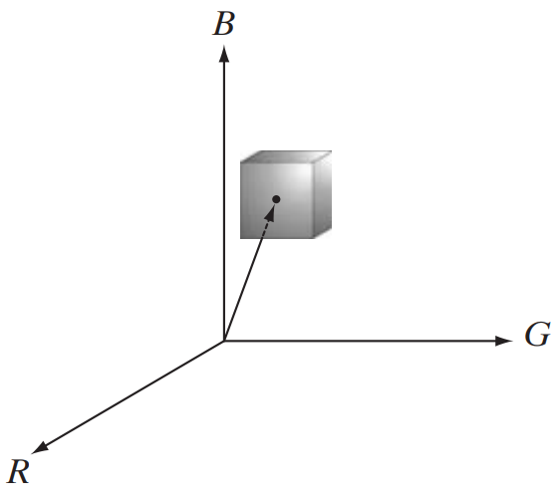

If we really want to get a sphere (or an ellipsoid), we need to add a **distance**, i.e., instead of defining $c$ as $c=\left[\begin{matrix}r+σ \\ g+σ \\ b+σ\end{matrix}\right]$, we define it as $c=\left[\begin{matrix}r \\ g \\ b\end{matrix}\right]+d$, where $d$ is the maximum distance allowable from the refence point. There are two popular ways in which we can calculate the distance between the reference, $z$, and some other point, $a$. These are:

1. Euclidean Distance, which gives a spherical shape
$$D\left(z,a\right)=\left|\left|z-a\right|\right|$$

$$={\left[{\left(z-a\right)}^{T}\left(z-a\right)\right]}^{\frac{1}{2}}$$

$$={\left[{\left(z_{R}-a_{R}\right)}^{2}+{\left(z_{G}-a_{G}\right)}^{2}+{\left(z_{B}-a_{B}\right)}^{2}\right]}^{\frac{1}{2}}$$

2. Mahalanobi’s Distance, which allows for an elliptical shape

$$D\left(z,a\right)={\left[{\left(z-a\right)}^{T}C^{-1}\left(z-a\right)\right]}^{\frac{1}{2}}$$

Here, $C$ is the **covariance matrix**, which can be manipulated to create an elliptical shape instead of a spherical one.

## Edge Detection

For **edge detection**, we can simply apply one of the edge detection filters, such as the Sobel filter, on each of the channels in the RGB model. We can then get the sum of the results from each of the channels to get the final output. For the following red, green and blue channels, we will get a **strong response** for $G_{y}$ at the edge, but no response for $G_{x}$.



However, doing this can sometimes lead to **erroneous results**. Suppose we have the following red, green and blue channels.

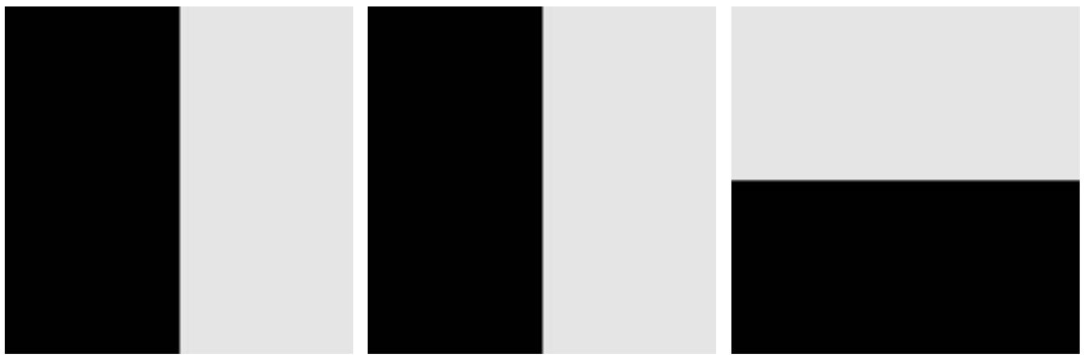

These channels will produce the following image:



We get a blue colour on the top-left corner because the intensity of red and green in that corner is 0 while the intensity of blue is high. We get a yellow colour on the bottom-right corner because the intensity of red and green is high in that corner while the intensity of blue is 0.

If we try to get the **vertical edge** from the different channels, we will get a response for the red and green channels, but no response for the blue channel. As a result, the total $G_{y}$ will be **less strong** that it was for the previous image. However, the **combined colour image** shows us that there is a very **visible vertical edge**, so we should be getting a **strong response** for $G_{y}$.

In order to bypass this error, we need to calculate the gradient in the **vector space** instead of splitting the colour image into separate red, green and blue channels.

$u=\frac{δR}{δx}r+\frac{δG}{δx}g+\frac{δB}{δx}b$ $v=\frac{δR}{δy}r+\frac{δG}{δy}g+\frac{δB}{δy}b$

Here, $r$, $g$ and $b$ are the unit vectors along the $R$, $G$ and $B$ axes respectively. Thus, $u$ gives us the change in the $x$-direction for each channel and $v$ gives us the change in the $y$-direction for each channel.

From this,

$g_{xx}=u^{T}u$ $g_{yy}=v^{T}v$ $g_{xy}=u^{T}v$

$$θ\left(x,y\right)=\frac{1}{2}\tan^{-1}\left[\frac{2g_{xy}}{g_{xx}-g_{yy}}\right]$$

$$F_{θ}\left(x,y\right)={\left\{\frac{1}{2}\left[\left(g_{xx}+g_{yy}\right)+\left(g_{xx}-g_{yy}\right)\cos{2θ\left(x,y\right)}+2g_{xy}\sin{2θ\left(x,y\right)}\right]\right\}}^{\frac{1}{2}}$$

Typically, there is a large difference between the edges found using this complicated method and the previous simpler method. However, the lack in accuracy is usually ignored and the simpler method is used.

## Noise

If we have Gaussian noise in a colour image, under the RGB model, we can apply an averaging filter to each of the red, green and blue channels to remove the noise. If we shift to the **HSI model**, we will see that surprisingly, the intensity channel is less affected by noise than the hue and saturation channels are.

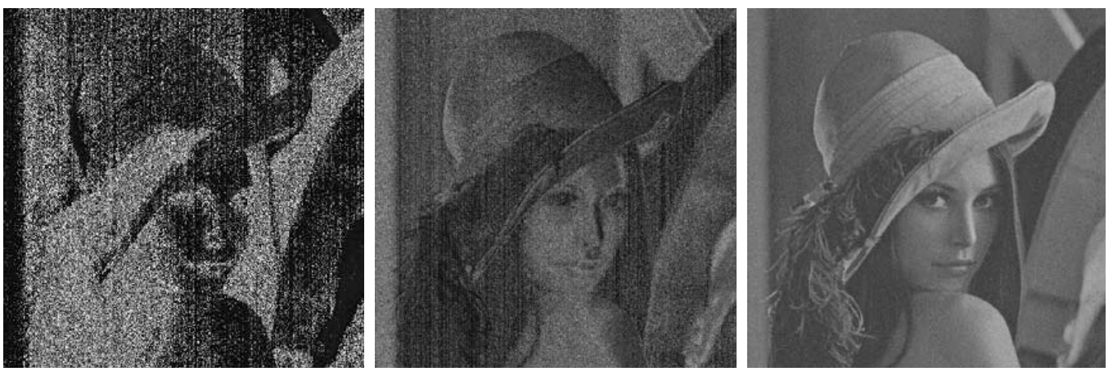

The reason this occurs is because the intensity channel is the **average** of the red, green and blue channels.

$$I=\frac{1}{3}\left(R^{n}+G^{n}+B^{n}\right)$$

This averaging reduces the noise.

The above scenario only occurs for Gaussian noise. In the case of salt-and-pepper noise, the averaging does not help to reduce noise. Thus, we will see noise in all of the hue, saturation and intensity channels.

## Image Compression

**Compression** is the process of reducing or eliminating redundant and/or irrelevant data. Ideally, the compressed version of the image is not noticeably different from the original. This will be covered in later chapters, but the idea is essentially to use fewer bits to encode information when we have similar colours.